**Designing a Sales dashboard in Excel.**

DESCRIPTION

Use Excel to analyze the sales based on various product categories.

**Description:**

The dataset in file **E-Commerce Dashboard dataset.xlsx**contains sales data for different product categories. The following are the features in the dataset:

|  |  |
| --- | --- |
| Order ID | Unique Order ID of a product |
| Order Date | Order Placement Date |
| Ship Date | Shipment Date of the placed order |
| Aging | Used to Create Histogram Bin |
| Ship Mode | Shipment mode of placed order |
| Product Category | Product Category |
| Product | Name of the Product |
| Sales | Sales Amount |
| Quantity | The amount or number of a material |
| Discount | A deduction from the usual cost of something |
| Profit | A financial advantage or benefit |
| Shipping Cost | The amount required to ship the placed order |
| Order Priority | Precedence of placed order |
| Customer ID | Unique Customer ID |
| Customer Name | Name of the Customer |
| City | Unique City Name |
| State | Unique State Name |
| Country | Unique Country Name |
| Region | Especially the part of a country |
| Months | The month of placing the order |

The following project tasks are required to be performed in Excel:

* Use the saved Sample E-Commerce database
* Prepare a table of Sales and Profit month-wise in a working sheet
* Prepare the sales table region-wise in the working sheet
* Create User Control Combo box for Product Category
* Create a Column Chart of the month-wise table and region-wise table
* Link the table with a combo box
* Create a dashboard.

**Tools required:** Microsoft Excel, Data Analysis Add-in

**Expected Deliverables:**Design a sales dashboard that analyzes the sales based on various product categories. The company wants to add user control for product category so that users can select a category and can see the trend month-wise and product-wise accordingly.

File of an e-Commerce Dashboard Project Screenshot is displayed below

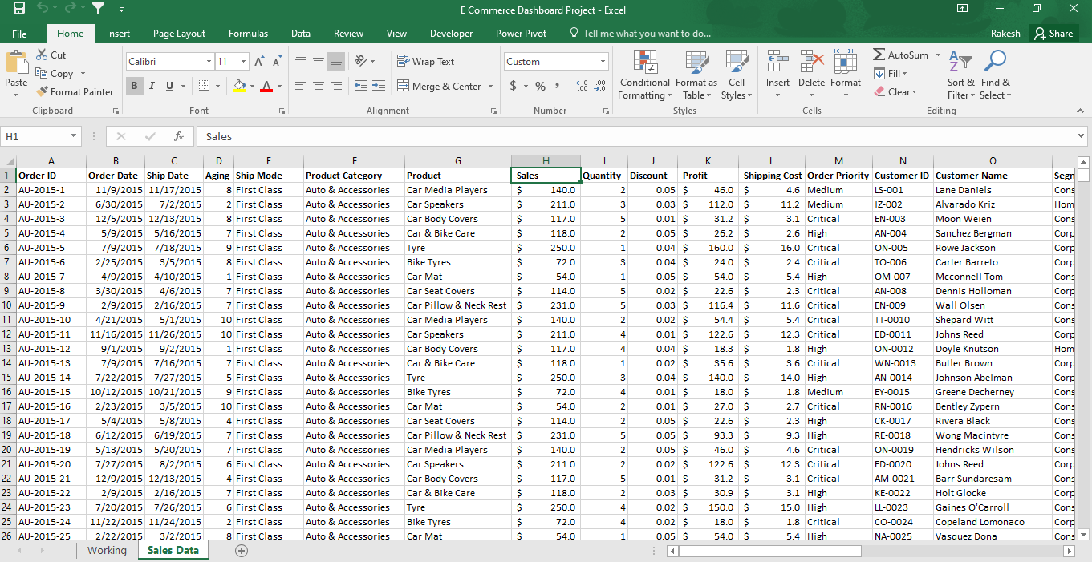

For dataset click on [E Commerce Dashboard Project.xlsx](https://github.com/swetharsunkara/E-Commerce-Dashboard/blob/main/E%20Commerce%20Dashboard%20Project.xlsx)

Select all the data from Sales Data sheet; create a Pivot Table by selecting Row as Months, Values as Sales and Profit. Select the Sum of Sales & Sum of Profit Columns and Rename as Monthly Sales and Monthly Columns.

Select the Monthly Sales & Monthly Profit columns and click on Format Cells and select Number with 0 decimal.

Rename the sheet as Working Data.

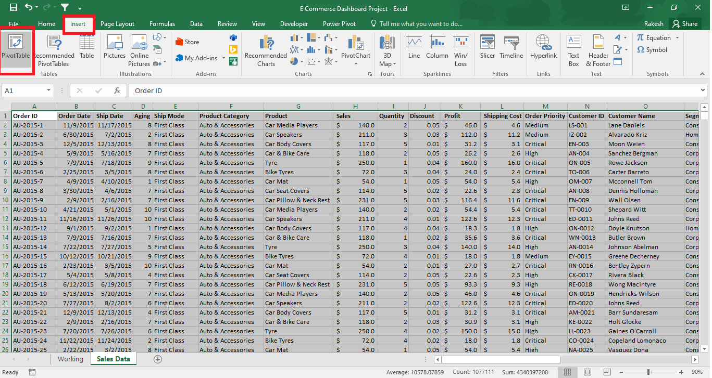

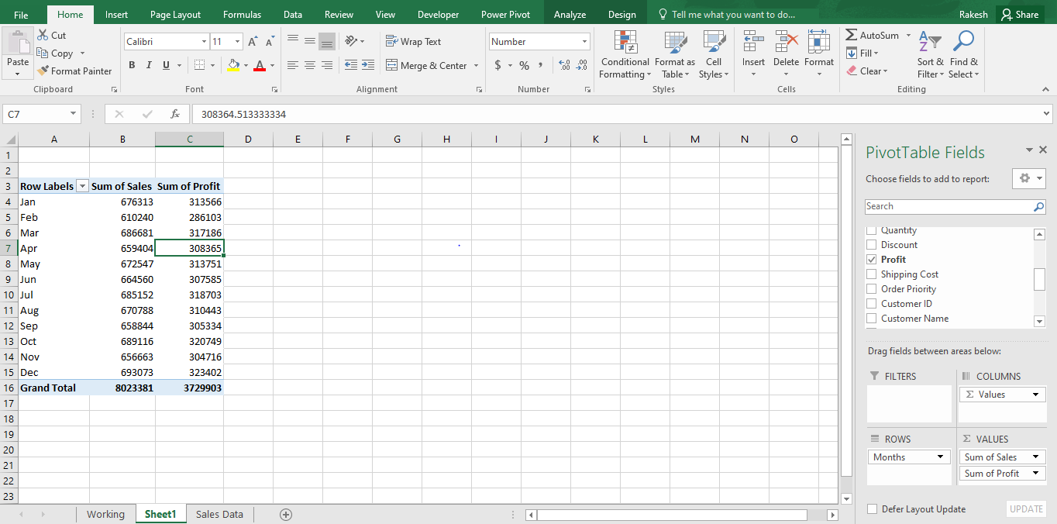

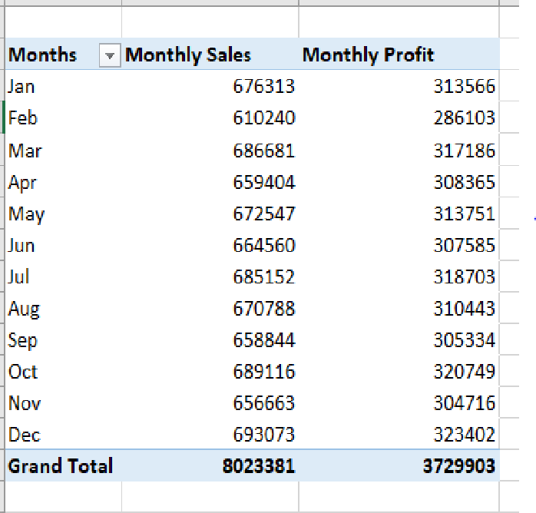

Create a Pivot table on same page for Regions & Sales

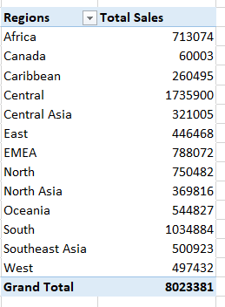

Calculate the sales by using formula =SUMIFS('Sales Data'!H2:H51291,'Sales Data'!F2:F51291,'Working Data'!U6)

Note: Make sure you enter the cell number properly to get required output

3. List the Product Category with numbers as shown below and do vlookup so that when user enters the number, category is displayed in the cell.

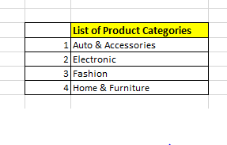

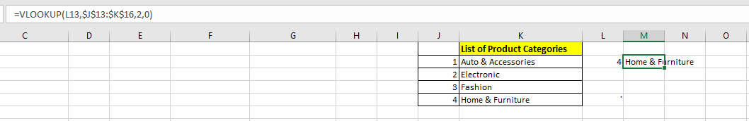

Vlookup formula used here is =VLOOKUP(L13,$J$13:$K$16,2,0)

Note: Make sure you enter the cell number properly to get required output

4. Create a Combo Box – To create combo box go to Developer, click on Insert and select Combo box.

5. Create Combo box for Product Category and select the Input Range and Cell Link

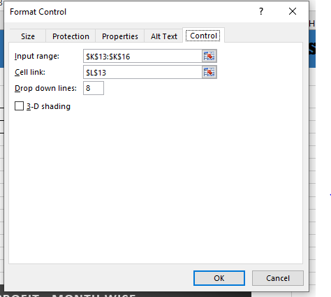

6. Linkage of Sales, Quantity & Profit Tables with the Combo box.

Sales : =SUMIFS('Sales Data'!H2:H51291,'Sales Data'!F2:F51291,Dashboard!M13)

Quantity: =SUMIFS('Sales Data'!I2:I51291,'Sales Data'!F2:F51291,Dashboard!M13)

Profit: =SUMIFS('Sales Data'!K2:K51291,'Sales Data'!F2:F51291,Dashboard!M13)

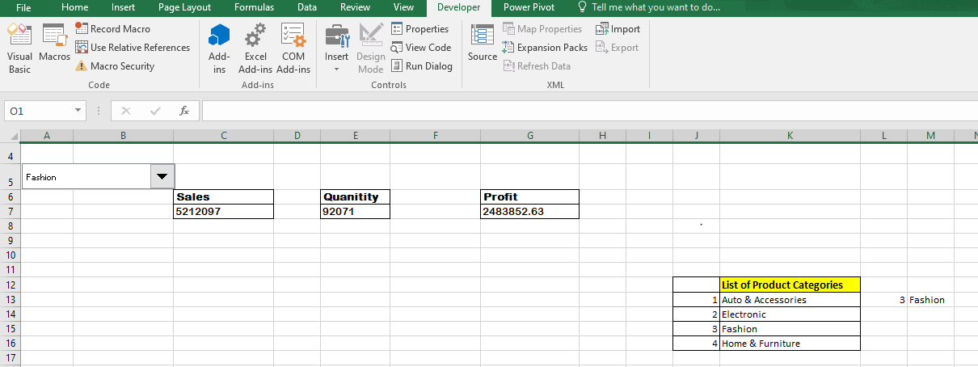

Create Dashboard